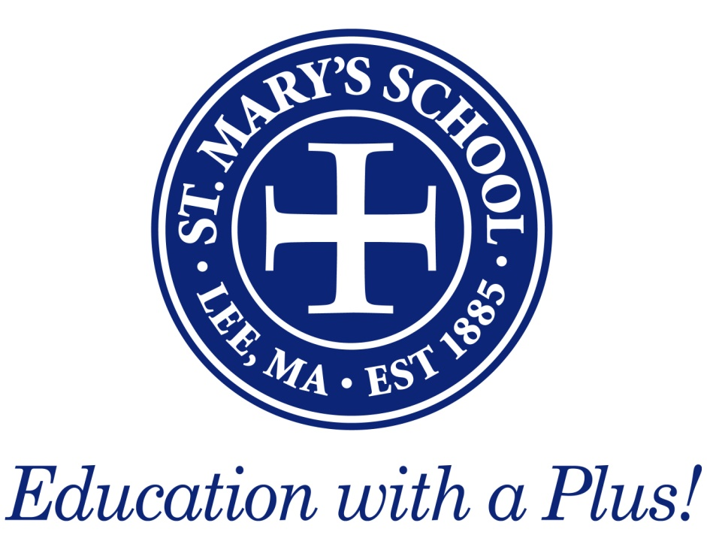
Active & Involved
Most parishes will want three things to give you the subsidy:
- Be a registered parishioner who gives to the parish.
- Go to church on a regular basis.
- Do some form of service.
Let’s show them that we have active and involved Catholic families.
ST. MARY’S SCHOOL
115 Orchard Street | Lee, Massachusetts 01238-1399
(413) 243-1079 Main | (413) 243-1022 FAX

CATHOLIC PARISH SUBSIDY FORM
2021 - 2022 Academic Year

Many of our students have received parish subsidies from their home parish. In order to qualify for a parish subsidy, please follow the following process.

- Contact your Parish Office to determine if a parish subsidy program is available.
- If a program is available, have your pastor (including Fr. Brian at St. Mary’s Lee) complete and return this form to:

St. Mary’s School
Attn: Holly Cusack – Business Office
115 Orchard Street
Lee, MA 01238-1399

- Your tuition will be adjusted by the level of support indicated by your pastor. An adjustment will be made to your monthly payments or a refund will be issued if tuition was paid in full. Under no circumstance will a parish subsidy be applied without the completed form.

Parent Name:

Address:

City / Sate / Zip Code:

Phone:

Parish: Town:

STUDENT NAME | GRADE IN SEPT. 2021 | AMOUNT OF SUBSIDY
 | Total Subsidy Approved:

Approved by:
(Pastor)

