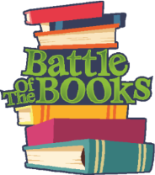
Battle of the Books
Grade Level Book Lists
2018 – 2019

:: Medium 20 Book List 7-8 Grades 2018-19 ::
Author | Title
Black, Holly | Doll Bones
Blos, Joan | A Gathering of Days
Burnford, Sheila | The Incredible Journey
Byars, Betsy | The Pinballs
Clements, Andrew | The School Story
Curtis, Christopher | The Watsons Go to Birmingham
Cushman, Karen | The Midwife’s Apprentice
Erskine, Kathryn | Mockingbird
Flake, Sharon | The Skin I’m In
Fox, Paula | One-Eyed Cat
George, Jean Craighead | Julie of the Wolves
Henkes, Kevin | Protecting Marie
Horvath, Polly | Everything on a Waffle
Korman, Gordon | Swindle
Levine, Ellen | If Your Name Was Changed at Ellis Island
Park, Linda Sue | A Long Walk to Water
Peck, Richard | A Long Way from Chicago
Ryan, Pam | Becoming Naomi Leon
Spinelli, Jerry | Maniac Magee
Staples, Suzanne Fisher | Shabanu: Daughter of the Wind

