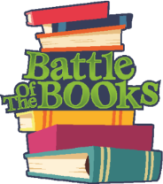
Battle of the Books
Grade Level Book Lists
2018 – 2019

:: Medium 20 Book List 5-6 Grades 2018-19 ::
Author | Title
Applegate, Katherine | Crenshaw
Avi | The Secret School
Banks, Lynne | The Indian in the Cupboard
Cole, Henry | A Nest for Celeste: a Story About Art Inspiration and the Meaning of Home
DiCamillo, Kate | The Tale of Despereaux
George, Jessica Day | Tuesdays at the Castle
Haddix, Margaret | Running Out of Time
Harlow, Joan Hiatt | Midnight Rider
Jamieson, Victoria | Roller Girl
Korman, Gordon | Slacker
Lewis, C.S. | Chronicles of Narnia: Lion, Witch, & the Wardrobe
Lewis, Gill | Wild Wings
Naylor, Phyllis Reynolds | Shiloh
Park, Linda | The Kite Fighters
Peck Richard | Secrets At Sea
Sachar, Louis | Sideways Stories from Wayside School
Shahan, Sherry | Frozen Stiff
Stewart, Trenton | The Mysterious Benedict Society
Taylor, Theodore | The Trouble with Tuck
Urban, Linda | A Crooked Kind of Perfect

